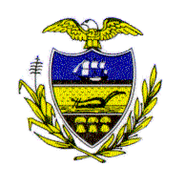Allegheny County Council

Proclamation

WHEREAS, for four decades Urban Youth Action Inc. (UYA), located in Pittsburgh, Pennsylvania, has been empowering youth to be “Work Ready, Life Prepared and Community Minded;” and

WHEREAS, 2006 marks the 40th Anniversary of Urban Youth Action, and to celebrate and help raise funds for the nonprofit organization, Andrew and Janae Frazier are hosting a New York City Harbor Holiday Cruise on December 30th aboard the ship “Spirit;” and

WHEREAS, the cruise will sail from Lincoln Pier in Weehawken, New Jersey, with friends, supporters and family of Urban Youth Action, as well as special guest speaker Dr. Audrey Murrell, Board Chair and Professor at the University of Pittsburgh; and

WHEREAS, Urban Youth Action, now led by Executive Director Karris M. Jackson, was founded by the late Bernard H. Jones, Sr. to help young people in preparing them for the opportunities available in education, employment, entrepreneurship and public service; and
- WHEREAS, UYA encourages minority business ownership, offers life-skills development, work experience and career exposure through internship placements, builds mentoring relationships for students with specific career goals and provides information regarding post-high school education; and
WHEREAS, UYA is co-administered by high school students employed as youth staff who assist in the implementation of programs and activities;
NOW, THEREFORE BE IT RESOLVED, that Allegheny County Chief Executive Dan Onorato and Allegheny County Council do hereby recognize the accomplishments of Urban Youth Action, Inc. and join in celebrating its 40th Anniversary.

Co-sponsored by Chief Executive
Dan Onorato and Council Member Brenda Frazier,
and presented this 23rd day of January 2007.
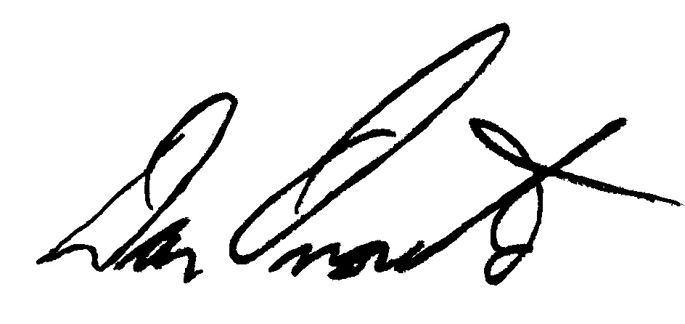
Dan Onorato, Allegheny County Chief Executive

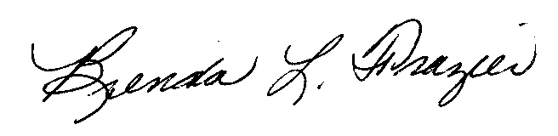

Brenda Frazier, Allegheny County Council Member

