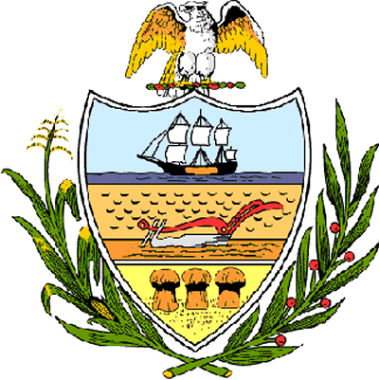

County of Allegheny

Office of the County Council

Certificate of Achievement
Awarded to

Mr. Daniel J. Fahringer
Troop #215

This Certificate of Achievement is awarded to you in recognition of earning the rank of Eagle Scout, scouting’s most distinguished honor. We commend you on the diligence and skill you displayed throughout your scouting service, on your growth through Troop leadership positions and on the perseverance you displayed throughout your scouting career. This Council extends its deepest appreciation for your service to the community in which you coordinated the efforts of 34 people to clean and paint two hallways, two bathrooms and a classroom at Mt. Lebanon United Presbyterian Church. You have set a high standard of commitment and dedication which the youth of our great County of Allegheny may follow, and which serves as an inspiration to this Council and the citizens of Allegheny County.

Sponsored by Council Member Vince Gastgeb
Presented on behalf of Allegheny County Council and the citizens of Allegheny County this 12th day of September, 2006.

Attest:
_______________________________
John Mascio
Clerk of Council

