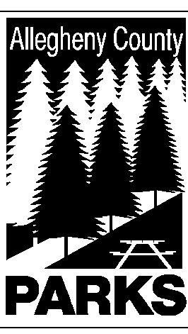

ALLEGHENY COUNTY DEPARTMENT OF PARKS

SUMMARY OF LEGISLATION

TO: WILLIAM McKAIN, COUNTY MANAGER BARBARA M. PAREES, DEPUTY COUNTY MANAGER
STEPHEN E. PILARSKI, DEPUTY COUNTY MANAGER

CC: ANDREW F. SZEFI, COUNTY SOLICITOR
FROM: Andrew G. Baechle, Director of Parks

DATE: September 30, 2014

RE: BOYCE PARK – WESTERN PA POLICE ATHLETIC LEAGUE, INC.
______________________________________________________________________

The Department of Parks respectfully requests authorization to use the property known as the Maintenance Barn located on Center Road in Boyce Park for the Western PA Police Athletic League, Inc. This is a continuous use of property by the League.

Please do not hesitate to contact Andrew Baechle at 412-350-2460 if you have any questions or need additional information.

AGB/lg

