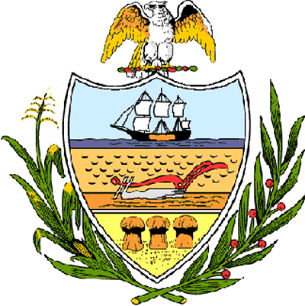

County of Allegheny

Office of the County Council

Certificate of Achievement
Awarded to

Reverend Dr. Johnnie Monroe

This Certificate of Achievement is awarded to you for earning the Pennsylvania Human Relations Commission 50th Anniversary Celebration Award presented on April 11, 2006 in Pittsburgh, Pennsylvania. The Pennsylvania Human Relations Commission honored you for your extraordinary leadership, commitment and dedication to the advancement of civil rights and equal opportunity. Allegheny County Council hereby salutes and recognizes your accomplishments, expresses its appreciation to you for your past and ongoing contributions to the community and commends you on being named a leader of promoting diversity and equality. You have set a high standard of commitment and dedication which the citizens of our great County of Allegheny may follow, and which serves as an inspiration to this Council and to the residents of Allegheny County.

Sponsored by Council Member Brenda Frazier
Presented on behalf of Allegheny County Council and the citizens of Allegheny County this 2nd day of May, 2006.

Attest:

_______________________________
John Mascio
Clerk of Council

