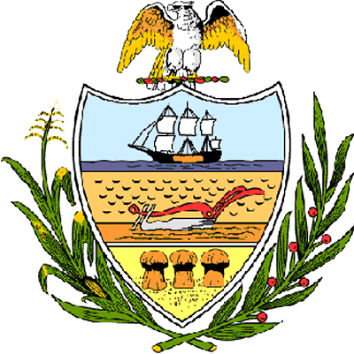

County of Allegheny

Office of the County Council

Certificate of Achievement
Awarded to

BETHEL PARK SENIOR HIGH SCHOOL

2007 Girls’ Swimming Team

Allegheny County Council is proud to present this Certificate of Achievement in recognition of the outstanding athletic abilities of the Bethel Park Senior High School Girls’ Swimming Team which contributed to the team’s outstanding season in which it earned the 2007 WPIAL Class AAA Girls’ Swimming Championship. This distinguished endeavor and accomplishment is worthy of our County of Champions, earning the esteem of the citizens of Allegheny County. Your achievement has conferred honor upon the County to be shared by each of us and, for that, we commend you.

Sponsored by Council Member Vince Gastgeb, and presented on behalf of Council and the citizens of Allegheny County this 4th day of April, 2007.

Attest:
_______________________________
John Mascio
Clerk of Council

