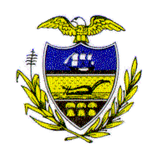Allegheny County Council

Proclamation

WHEREAS, 2007 marks the Allegheny County Health Department’s 50th anniversary; and

WHEREAS, since 1957, the Allegheny County Health Department has played an important role in the community, serving our County’s 1.2 million residents through prevention, promotion and protection of public health; and

WHEREAS, throughout its history the Health Department has reached numerous milestones, including everything from vaccinating kids against polio in the early years to building a new state-of-the-art lab for bioterrorism testing; and

WHEREAS, these accomplishments are worthy of our praise, and we commend the Allegheny County Health Department for its outstanding efforts towards protecting public health, as well as our air, water, food and the environments where we live, work and play;

NOW, THEREFORE, BE IT RESOLVED that Allegheny County Council does hereby recognize and honor the Allegheny County Health Department upon the momentous occasion of its 50th anniversary. This Council wishes to express the pride Allegheny County takes in the Health Department’s contributions and services to all citizens of Allegheny County.

Sponsored by All Council Members, and presented on behalf of Allegheny County Council and the citizens of Allegheny County this 17th day of April 2007.

Attest:
_________________________ ___________________________
President of Council John Mascio
Rich Fitzgerald Chief Clerk of Council

