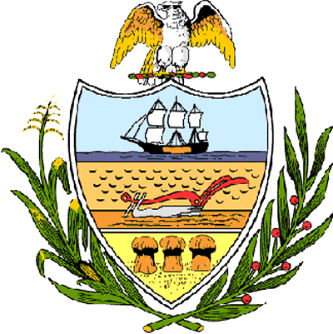

County of Allegheny

Office of the County Council

Certificate of Achievement
Awarded to

QUAKER VALLEY HIGH SCHOOL

2006 Girls’ Tennis Team

Allegheny County Council is proud to present this Certificate of Achievement in recognition of your outstanding athletic ability, a quality clearly shared by your teammates, which contributed to the team’s outstanding season in which it earned the 2006 WPIAL Class AA Championship. This distinguished endeavor and accomplishment is worthy of our County of Champions, earning the esteem of the citizens of Allegheny County. Your achievement has conferred honor upon the County to be shared by each of us and, for that, we commend you.

Sponsored by Council Member Matt Drozd and presented on behalf of Council and the citizens of Allegheny County, this 19th day of December 2006.

Attest:

_______________________________
John Mascio
Clerk of Council

