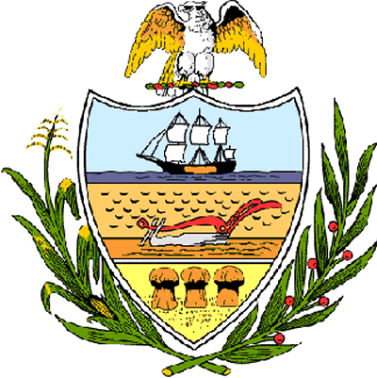

County of Allegheny

Office of the County Council

Certificate of Achievement
Awarded to

Ms. Emily Wooddell

This Certificate of Achievement is awarded to Ms. Emily Wooddell, a sophomore at Baldwin High School, for winning 1st Place in the Jefferson Regional Medical Center’s poster contest sponsored by its Community Health Council. The annual poster contest is an outreach effort which encourages students to create posters in two mediums, visual artwork and digital graphic design. Community Health Council Members judged the artwork based on creativity and relevance to this year’s theme, which was “What makes Jefferson Regional Medical Center an important part of our community?” Emily’s poster depicted a globe in the hands of a healthcare worker, with the words “help, healing, hope and care” surrounding the image. Emily will receive a cash award and will participate in Jefferson Regional Medical Center’s Community Recognition Night on August 28, 2007. Your achievement has set a high standard of commitment and dedication which the youth of our great County of Allegheny may follow and serves as an inspiration to this Council and the citizens of Allegheny County.

Sponsored by Council Member Joan Cleary and presented on behalf of Allegheny County Council and the citizens of Allegheny County, this 28th day of August 2007.

Attest:
_______________________________
John Mascio
Clerk of Council

