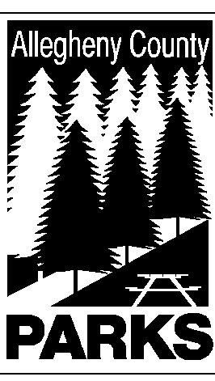

ALLEGHENY COUNTY DEPARTMENT OF PARKS

SUMMARY OF LEGISLATION

TO: MIKE WOJCIK, COUNTY SOLICITOR
CC: DEREK UBER, ASST. COUNTY MANAGER

FROM: Andrew Baechle, Director of Parks

DATE: December 28, 2005

RE: SOUTH PARK BOXING, INC.

The Department Parks respectfully requests authorization for the continuing use of property known as EXHIBIT BUILDING #11 located in SOUTH PARK for SOUTH PARK BOXING, INC.

This is a continuous use of property by the boxing organization.

Please do not hesitate to contact Peter J. Wagner at 350-3167 if you have any questions or need additional information.

