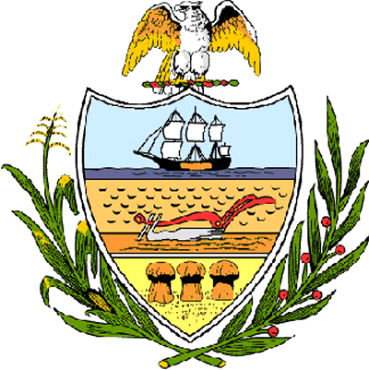

County of Allegheny

Office of the County Council

Certificate of Achievement
Awarded to

Mr. Zachary Brown
Troop # 274

This certificate of achievement is awarded to Mr. Zachary Brown in recognition of earning the rank of Eagle Scout, scouting’s most distinguished honor. We commend you on the diligence and skill you displayed throughout your scouting service, on your growth through Troop leadership positions, and on the perseverance you displayed throughout your scouting career. This Council extends its deepest appreciation for your service to your community in which you removed a downed tree that was blocking city steps that connect Stanton Heights to a shopping center and bus line in Lawrenceville, removing overgrowth from those steps and repairing and painting 400 feet of railings. You have set a high standard of commitment and dedication which the youth of our great County of Allegheny may follow, and which serves as an inspiration to this Council and the citizens of Allegheny County.

Sponsored by Council President Rich Fitzgerald
Presented on behalf of Allegheny County Council and the citizens of Allegheny County this 19th day of November, 2006.

Attest:

_______________________________
John Mascio
Clerk of Council

