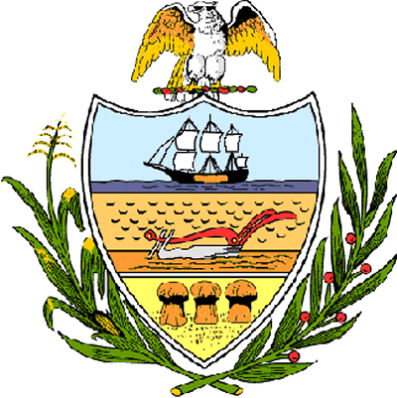

County of Allegheny

Office of the County Council

Certificate of Achievement
Awarded to

PRC – West Mifflin, Pennsylvania

This Certificate of Achievement is awarded to PRC’s West Mifflin center in recognition of receiving three major awards and recognitions for their dedicated work as a top employer giving back to the community. The Mon Valley Initiative named PRC West Mifflin as the 2007 Employer of the Year. PRC also received the Governor’s Workforce Development Award for Western Pennsylvania, and they will receive the James F. Compton Humanitarian Award from Life’sWork of Western Pennsylvania this fall. PRC is an outsourced business solutions provider globally delivering customer management and sales & marketing services on behalf of leading brands. We congratulate PRC West Mifflin for this most impressive accomplishment and we thank them for their dedication, commitment, and efforts to serve the public, which serves as an inspiration to this Council and the citizens of Allegheny County.

Sponsored by Council Member Bob Macey and presented on behalf of Allegheny County Council and the citizens of Allegheny County this 27th day of July 2007.

Attest:
_______________________________
John Mascio
Clerk of Council

