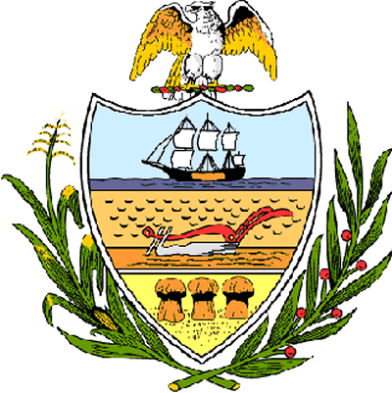

County of Allegheny

Office of the County Council

Certificate of Achievement
Awarded to

Lucas Zarzeczny

2006 PIAA and WPIAL AA Individual Cross Country Champion

Allegheny County Council is proud to present this Certificate of Achievement in recognition of your outstanding athletic ability, which contributed to your winning both the 2006 PIAA and WPIAL AA Individual Cross Country Championship. This distinguished endeavor and accomplishment is worthy of our County of Champions, earning the esteem of the citizens of Allegheny County. Your achievement has conferred honor upon the County to be shared by each of us and, for that, we commend you.

Sponsored by Council Member Matt Drozd and presented on behalf of Council and the citizens of Allegheny County, this 19th day of December 2006.

Attest:

________________________
John Mascio
Clerk of Council

