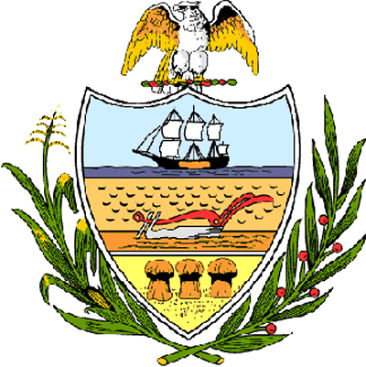

County of Allegheny

Office of the County Council

Certificate of Achievement
Awarded to

Paul Jackson
House of David

This Certificate of Achievement is awarded to you in recognition of your hard work and efforts in providing oversight and guidance to the students participating in the 2006 Power of Youth in Government Program. Your community commitment and dedication sets a positive example of excellence for all of Allegheny County. We hereby officially commend you on this distinguished accomplishment, which has earned the respect and esteem of this Council and the citizens of Allegheny County.

Sponsored by Council Member William Russell Robinson

Presented by County Council on behalf of the citizens of Allegheny County, this 7th day of March, 2006.

Attest:

______________________________________ Clerk of Council
John Mascio

