Bill No. ___________________

No. ___________________

A RESOLUTION

A Resolution of the Council of Allegheny County, Pennsylvania amending Resolution No. 24-14-RE to expand the “Three Crossings” LERTA District in the City of Pittsburgh to include six (6) additional parcels

Whereas, Pennsylvania’s Local Economic Revitalization Tax Assistance Act, Pa. Stat. Ann. tit. 72, § 4722 et seq., (1995), as amended, (hereinafter referred to as “LERTA”) authorizes local taxing authorities to enact a program whereby any increases in the assessed valuation of real property for the assessment and levying of real property taxes that is attributable to improvements made by the owner of an industrial, commercial, and other business property located within the geographic confines of a local taxing authority area determined to be deteriorating can be temporarily exempted based upon a schedule establishing the portion of the assessed valuation of the improvements to be exempted within a particular year after the improvements have been made; and

Whereas, on September 9, 2014, at the request of the City of Pittsburgh, Allegheny County Council enacted Resolution 24-14-RE establishing a LERTA program exempting increases in assessed valuation resulting from improvements made to industrial, commercial, and other business property within the Three Crossings LERTA District from County real property taxation; and

Whereas, Oxford Development Company (“Developer”) has requested that the County amend Resolution No. 24-14-RE to include six (6) additional parcels in the Three Crossings LERTA District so that any increases in assessed valuation resulting from improvements made to industrial, commercial, and other business property on these six (6) parcels would also be exempt from County real property taxation; and

Whereas, the Council of the County of Allegheny finds that inclusion of these six additional parcels described below as part of the Three Crossings LERTA District would contribute to the general welfare of the citizens of Allegheny County by spurring economic activity and development.

The Council of the County of Allegheny hereby resolves as follows:

Section 1. Incorporation of Preamble.

The provisions set forth in the preamble to this Resolution are incorporated by reference in their entirety herein.

Section 2. Expansion of Three Crossing LERTA District.

Section 3 of Resolution No. 24-14-RE is deleted in its entirety and the following is substituted in its place:

Section 3 Inasmuch as the City, by and through its City Council, pursuant to public hearing, has determined that a specific area of the City of Pittsburgh, constitutes a “Deteriorated Area” within the purview of LERTA, County Council does hereby determine as a fact that the industrial, commercial, and other business property located within the geographic area or region within the City of Pittsburgh, as bounded and described in Exhibit A, which includes new parcels 25-J-160, 25-J-51, 25-J-49, 25-J-47, 25-J-182, 25-J-43 and is attached hereto, satisfy the criteria set forth in Section 4725 of LERTA and collectively constitute a “Deteriorated Area” for purposes of this Resolution.

Section 3. Effect on Other Provisions in Resolution No. 24-14 RE

Except as provided for in Section 3 above, all other provisions of Resolution No. 24-14-RE enacted September 9, 2014 shall remain in full force and effect.

Section 4. Severability.

If any provision of this Resolution shall be determined to be unlawful, invalid, void or unenforceable, then that provision shall be considered severable from the remaining provisions of this Resolution which shall be in full force and effect.

Section 5. Repealer.

Any Resolution or Ordinance or part thereof conflicting with the provisions of this Resolution is hereby repealed so far as the same affects this Resolution.

Enacted in Council, this __________ day of _________________________, 2015

Council Agenda No. __________________________

______________________________________
John DeFazio
President of Council

Attest: ________________________________
Jared Barker
Chief Clerk of Council

Chief Executive Office ________________________________, 2015

Approved: ___________________________________
Rich Fitzgerald
County Executive

Attest: __________________________________
Sonya Dietz
Executive’s Secretary

Exhibit A
Three Crossings

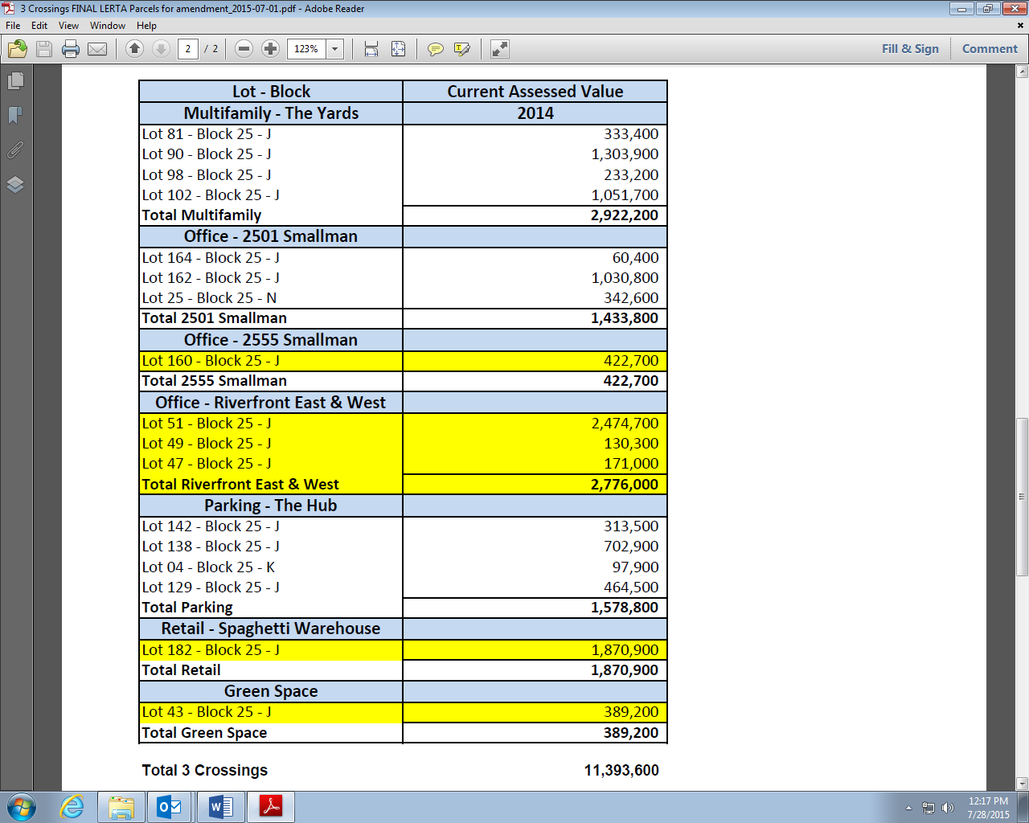

The following parcels are to be added to the LERTA District:
25-J-160
25-J-51
25-J-49
25-J-47
25-J-182
25-J-43

Three Crossings Amended LERTA District Map

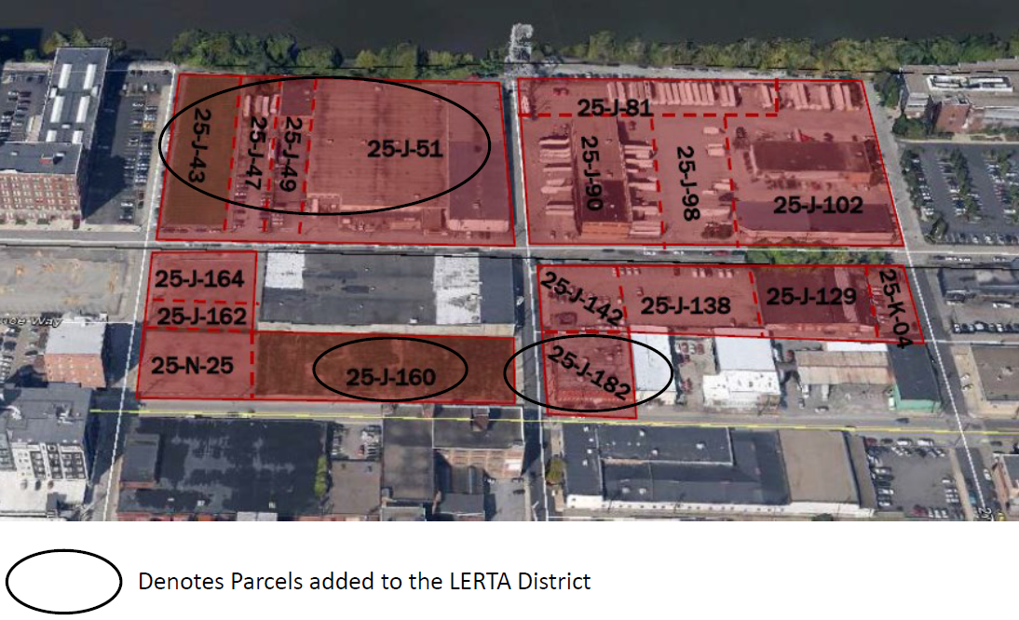

SUMMARY OF LEGISLATION
OXFORD DEVELOPMENT- THREE CROSSINGS LERTA SECOND AMENDMENT
SUBMITTED FOR COUNCIL MEETING SEPTEMBER 8, 2015

On September 9, 2014, County Council approved a resolution to participate with the City of Pittsburgh and Pittsburgh Public Schools in the implementation of a LERTA for a deteriorated area located in the Strip District neighborhood of the City of Pittsburgh. This District included the first phase of the $130 million mixed-use development, Three Crossings. Specifically, the District covered the 300-unit apartment complex, The Yards, and the first office building. The resolution was amended prior to its adoption by Council in order to change the effective date of the resolution from the date of adoption, to the latter of (1) the date of final approval of the resolution or (2) final approval of the exemption program by the City of Pittsburgh School District.

The developer is requesting a second amendment to the resolution in order to include six additional parcels, which make up the second phase of the Three Crossings development. This phase includes an additional 250,000 square feet of office space and the Hub, a multimodal transportation facility with parking for 578 vehicles plus 87 bicycles, storage for kayaks, electric charging stations, and approximately 13,000 sq. ft. of retail space. The development features European designed parking plazas that can be converted into public space, new street lighting, sidewalks, and other public infrastructure.

All other terms and conditions of the resolution are to remain the same.

