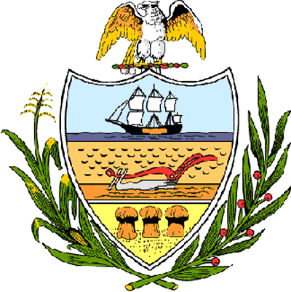

County of Allegheny

Office of the County Council

Certificate of Achievement
Awarded to

Pennsylvania Junior Academy of Science, Region 7 Meeting, February 4, 2006

This certificate of achievement is awarded in recognition of participating in the Pennsylvania Junior Academy of Science, Region 7 Meeting. We commend each student participant that conducted scientific investigations, prepared a written report, and presented an oral discourse on their findings, covering topics in biochemistry, behavioral science, biology, botany, chemistry, computer science, ecology, earth & space, math, microbiology, physics and zoology. This Council congratulates the school and the student participants for conducting research that may lead to the greater development of service to all through the field of science. You have set a high standard of commitment and dedication which the youth of our great County of Allegheny may follow, and which serves as an inspiration to this Council and to the citizens of Allegheny County.

Sponsored by Council President Rich Fitzgerald
Presented on behalf of Allegheny County Council and the citizens of Allegheny County this 4th day of April, 2006.

Attest:
_______________________________
John Mascio
Clerk of Council

