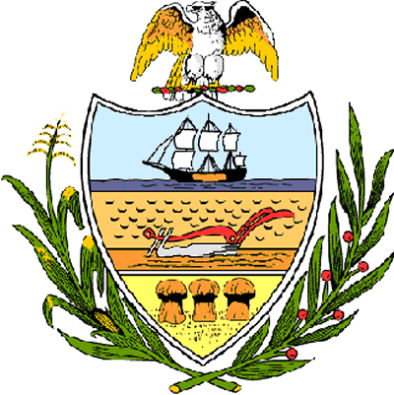

County of Allegheny

Office of the County Council

Certificate of Achievement
Awarded to
OASIS
Allegheny County
2005 Community Impact Award

This certificate of achievement is awarded in recognition of earning the 2005 Community Impact Award, a most distinguished honor. The Intergenerational Tutoring Program trained older adults as academic tutors. At-risk youth were paired one-on-one with these tutors to help increase both the reading and language skills of underdeveloped children. This Council expresses its gratitude for your dedication and commitment to serving the community. Your achievement has set a high standard which serves as an inspiration to this Council, as well as to the residents of Allegheny County.

Sponsored by Council Member Brenda Frazier
Presented on behalf of Allegheny County Council and the citizens of Allegheny County this 4th day of April, 2006.

Attest:

_______________________________
John Mascio
Clerk of Council

