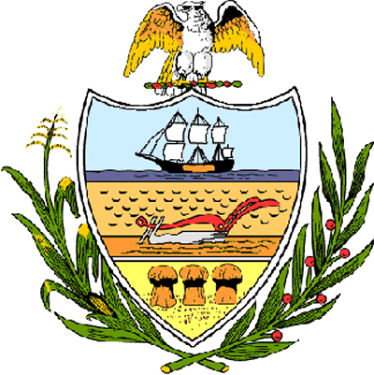

County of Allegheny

Office of the County Council

Certificate of Achievement
Awarded to

Ms. Natalie Blake
Troop # 824

This certificate of achievement is awarded to you in recognition of earning the Silver Award, one of scouting’s most distinguished honors.
This Council extends its deepest appreciation for your service to the Carrick Community in hosting a program for children at the Carrick Library. We commend you on your participation in numerous community activities; including Meals-on-Wheels, Project Linus and the Salvation Army’s Project Bundle-up. Your achievement has set a high standard of commitment and dedication which the youth of our great County of Allegheny may follow and serves as an inspiration to this Council and the citizens of Allegheny County. .

Sponsored by Council Member Joan Cleary
Presented on behalf of Allegheny County Council and the citizens of Allegheny County
This 1st day of March, 2005.

Attest:

_______________________________
John Mascio
Clerk of Council

