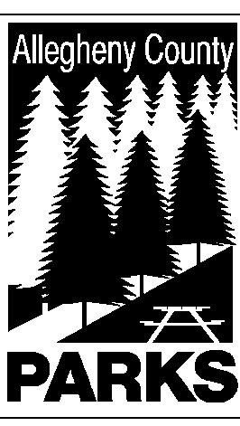

ALLEGHENY COUNTY DEPARTMENT OF PARKS

SUMMARY OF LEGISLATION

TO: WILLIAM McKAIN, COUNTY MANAGER BARBARA M. PAREES, DEPUTY COUNTY MANAGER
STEPHEN E. PILARSKI, DEPUTY COUNTY MANAGER

CC: ANDREW F. SZEFI, COUNTY SOLICITOR
FROM: Andrew G. Baechle, Director of Parks

DATE: January 5, 2015

RE: NORTH PARK – NORTH HILLS EAGLE SQUADRON
______________________________________________________________________

The Department Parks respectfully requests authorization to permit the use a piece of property located in North Park for the MODEL AIRCRAFT FIELD.

Please do not hesitate to contact Andrew Baechle at 412-350-2460 if you have any questions or need additional information.

AGB/lg

