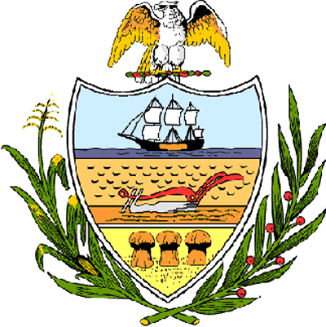

County of Allegheny

Office of the County Council

Certificate of Achievement
Awarded to

Allyson Sheehan
Baldwin High School

This Certificate of Achievement is awarded to Ms. Allyson Sheehan for her outstanding athletic ability, cooperation, citizenship and leadership. This Council congratulates you upon earning the 2005-2006 Bress Award, an honor bestowed upon the most outstanding female athlete at Baldwin High School. Excelling in three sports, indoor and outdoor track and cross-country for the Lady Highlanders’, making the Baldwin Athletic Honor Roll and being recognized as one of the most outstanding runners in school history is extraordinary. Your team spirit and positive attitude is worthy of our County of Champions. Your achievement has conferred honor upon the County to be shared by each of us and, for that, we commend you.

Sponsored by Council Member Joan Cleary
Presented on behalf of the citizens of Allegheny County by County Council, this 12th day of July 2006.

Attest:

______________________________________ Clerk of Council
John Mascio

