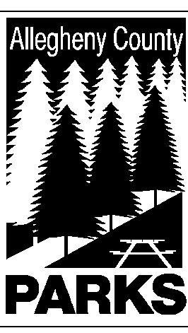

ALLEGHENY COUNTY DEPARTMENT OF PARKS

SUMMARY OF LEGISLATION

TO: WILLIAM McKAIN, COUNTY MANAGER BARBARA M. PAREES, DEPUTY COUNTY MANAGER
STEPHEN E. PILARSKI, DEPUTY COUNTY MANAGER

CC: ANDREW F. SZEFI, COUNTY SOLICITOR
FROM: Andrew G. Baechle, Director of Parks

DATE: January 2, 2015

RE: BOYCE PARK – FAMILY LINKS, INC.
______________________________________________________________________

The Department of Parks respectfully requests authorization to use the house located at 720 Center Road in Boyce Park for Family Links, Inc. This is a continuous use of property by the organization to provide programs and resources for at-risk families.

Please do not hesitate to contact Andrew Baechle at 412-350-2460 if you have any questions or need additional information.

AGB/lg

