A. Proposed Article XXI Revision – Nonattainment New Source Review

Deletions are shown with strikethroughs.
Additions are shown in larger font, bolded, and underlined.

. . .

§2102.06 MAJOR SOURCES LOCATING IN OR IMPACTING A NONATTAINMENT AREA

- Applicability. This Section shall apply to any new major facility, as defined by 25 PA Code 121.1 and to any major modification of an existing source which is located in a nonattainment area or transport region of the County or which will have a significant air quality impact on any nonattainment area or transport region. Procedures in 25 Pa. Code 127.203a shall be followed in determining whether any modification at a major source is determined to be a major modification.

….
f. Requirements for Modeling. Where air quality models are used to meet the provisions of this Section, modeling shall be based on the applicable models and other requirements specified in 40 CFR Part 51 Appendix W (Guideline on Air Quality Models). Where an air quality model specified in the Guideline on Air Quality Models is inappropriate, the model may be modified or another model may be substituted only on a case-by-case basis at the Department's discretion upon written approval by the Administrator of EPA. In addition, use of a modified or substituted model must be subject to notice and opportunity for public comment under procedures set forth in 40 CFR 51.102.

Exhibit “A”
B. Proposed Article XXI Revision – Coke Oven Pushing

Deletions are shown with strikethroughs.
Additions are shown in larger font, bolded, and underlined.

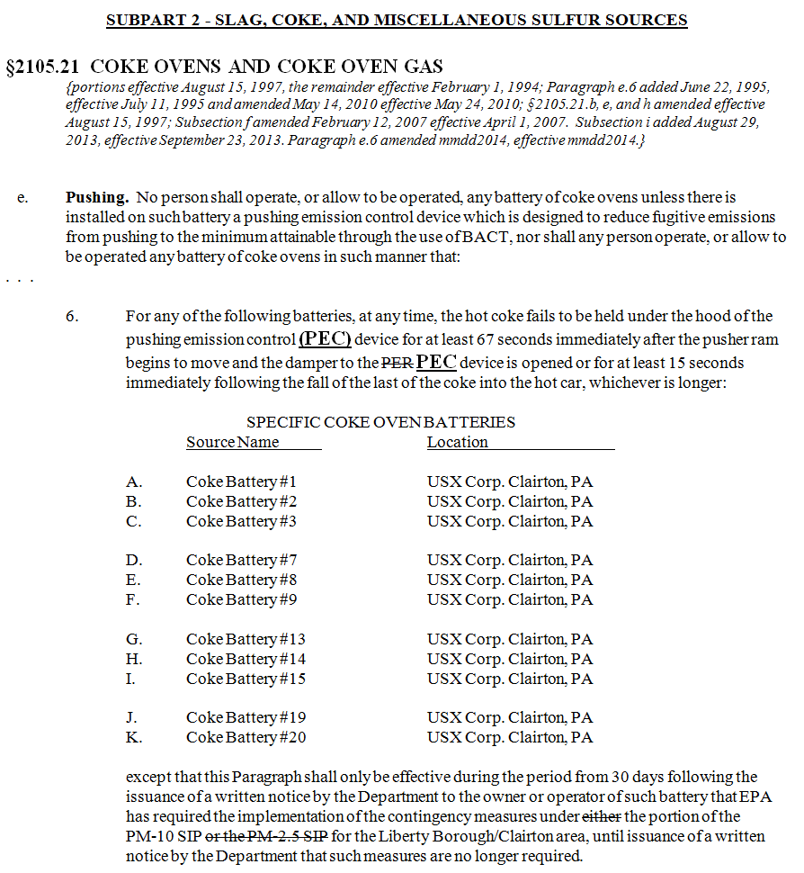

C. Proposed Article XXI Revision – Operating Permit Fees

Deletions are shown with strikethroughs.
Additions are shown in larger font, bolded, and underlined.

SUBPART 4 - OPERATING PERMIT FEES
. . .

§2103.41 EMISSIONS FEES
{Subsections a & c & Paragraph b.2 amended, and Paragraph b.1 added September 6, 1995, effective October 20, 1995; Subsections a & b amended May 7, 1998, effective May 15, 1998}

a. Annual Major Source Emissions Fee Requirements.

1. Except as otherwise provided herein, the The owner or operator of a source that requires a major Operating Permit pursuant to §2103.20 of this Article shall pay an Annual Major Source Emission Fee of $37 in the amount per ton set by the Department of Environmental Protection (DEP) under the regulations implementing the Air Pollution Control Act at 25 Pa. Code §127.705.a for each ton of a regulated pollutant actually emitted from the source. Provided, however, that the owner or operator shall not be required to pay an emission fee for emissions of more than 4,000 tons of each regulated pollutant from the source.

2. From the effective date of this Section through 1999, the owner or operator of a phase I affected unit or an active substitution unit as defined by Title IV of the Clean Air Act (42 U.S.C.A. Secs. 7661--7661f) shall pay an annual emission fee of $14 per ton for each ton of regulated pollutant actually emitted from the unit. Provided, however that the owner or operator shall not be required to pay an emission fee for emissions of more than 4,000 tons of each regulated pollutant from the source. Beginning in the year 2000, sources covered by this Paragraph shall pay the fees established in Paragraph a.1 above. The other provisions of this Paragraph notwithstanding, the owner or operator of a phase I affected unit or an active substitution unit as defined by Title IV of the Clean Air Act (42 U.S.C.A. Secs. 7661-7661f) shall not be required to pay more than $148,000 plus the increase established by Paragraph 4 below for each regulated pollutant emitted from a major source. Substitution units identified as conditional substitution units by the owner or operator shall pay the emission fee established by Paragraph a.1 above.

23. As used in this Section, the term “regulated pollutant” means a VOC; each pollutant regulated under sections 111 and 112 of the Clean Air Act (42 U.S.C.A. Secs. 7411 and 7412); and each pollutant for which a National Ambient Air Quality Standard has been promulgated, except that carbon monoxide shall be excluded from this reference.

4. The emission fee imposed under Paragraph a.1 above shall be increased in each year after 1995 by the percentage, if any, by which the Consumer Price Index for the most recent calendar year exceeds the Consumer Price Index for the previous calendar year. For purposes of this Paragraph:

A. The Consumer Price Index for a calendar year is the average of the Consumer Price Index for All-Urban Consumers, published by the United States Department of Labor, as of the close of the 12-month period ending on August 31 of each calendar year.

B. The revision of the Consumer Price Index which is most consistent with the Consumer Price Index for calendar year 1989 shall be used.

b. Annual Emissions Fee Deadline. In addition to any other administration fees required under this Article, the owners or operators of all sources subject to Subpart 2 of this Part shall pay annual emissions fees as set forth under Subsection (a) above for the previous calendar year actual emissions. Except as provided under Subsection (c) below, aAll such fees shall be paid into the "Allegheny County Air Quality Fund" for the major operating permit program as set forth under this Article. All such fees shall be paid by no later than September 1 of each year, beginning with September 1, 1998.

c. Annual Phase I Affected Source and Active Substitution Unit Emissions Fees. All annual emissions fees paid under Paragraph a.2 above shall be paid into the "Allegheny County Air Pollution Control Fund."

