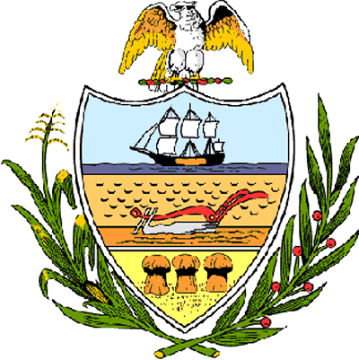

County of Allegheny

Office of the County Council

Certificate of Achievement
Awarded to

Mr. Doug Gulasy
B.S.A. Troop # 916

This Certificate of Achievement is awarded to Mr. Doug Gulasy in recognition of earning the rank of Eagle Scout, scouting’s most distinguished honor. We commend you on the diligence and skill you displayed throughout your scouting service, on your growth through Troop leadership positions, and on the perseverance you displayed throughout your scouting career. This Council extends its deepest appreciation for your service to your community in which you cleaned and painted four rooms and the hallways in the downstairs, one room upstairs and the toolshed outside for Wesley United Methodist Church. You have set a high standard of commitment and dedication which the youth of our great County of Allegheny may follow, and which serves as an inspiration to this Council and the citizens of Allegheny County.

Sponsored by Council Members Bob Macey, John DeFazio, and Dave Fawcett, and presented on behalf of Allegheny County Council and the citizens of Allegheny County this 17th day of April, 2007.

Attest:
_______________________________
John Mascio
Clerk of Council

