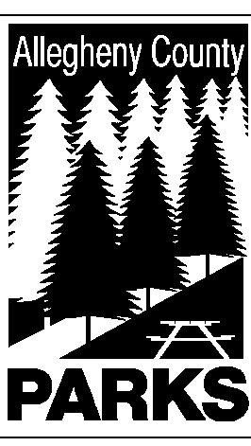

ALLEGHENY COUNTY DEPARTMENT OF PARKS

SUMMARY OF LEGISLATION

TO: JAMES FLYNN, COUNTY MANAGER
MIKE WOJCIK, COUNTY SOLICITOR
CC: DEREK UBER, ASST. COUNTY MANAGER

FROM: Andrew Baechle, Director of Parks

DATE: February 27, 2006

RE: WESTERN PENNSYLVANIA POLICE ATHLETIC LEAGUE – THE MON VALLEY EXPRESS DRUM AND BUGLE CORP

The Department Parks respectfully requests authorization to use the property known as EXHIBIT BUILDINGS #8 AND 10 located in SOUTH PARK for THE ABOVE ORGANIZATION.

Please do not hesitate to contact Peter J. Wagner at 350-3167 if you have any questions or need additional information.

