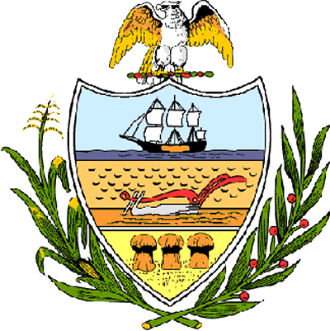

County of Allegheny

Office of the County Council

Certificate of Achievement
Awarded to
Community College of Allegheny County
Employees with 35 Years or More of Service

This Certificate of Achievement is awarded to you in recognition of your service as an employee with the Community College of Allegheny County for 35 years or more. We thank you for your time, commitment and efforts in education. Through your lifetime of dedication and professionalism, you have improved the lives of countless individuals and families. For these achievements and the many others throughout your career, Council bestows its highest commendation upon you. You have set a high standard of commitment and dedication which the residents of our great County of Allegheny may follow, and which serves as an inspiration to this Council and the citizens of Allegheny County.
Sponsored by Council Members Rich Fitzgerald, William Russell Robinson, Michael Finnerty, Matt Drozd, Sue Caldwell, Brenda Frazier, Joan Cleary, Bob Macey, Jan Rea, Dave Fawcett, John DeFazio, and Jim Burn. Presented on behalf of Allegheny County Council and the citizens of Allegheny County this 19th day of December, 2006.

Attest:
_______________________________
John Mascio
Clerk of Council

