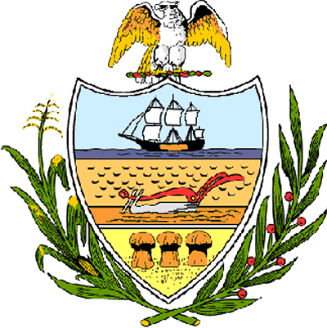

County of Allegheny

Office of the County Council

Certificate of Achievement
Awarded to
2006-2007 Deer Lakes High School Student Council

This Certificate of Achievement is awarded to you in recognition of your community service project in which you raised funds to host the annual Senior Citizen Holiday Luncheon. For over 30 years, the Student Council has been instrumental in soliciting support from local businesses and organizations to make the Senior Citizen Holiday Luncheon a special event. Student Council members have also assisted with good causes, such as, “Presents for Patients,” Central Blood Bank blood drives, the Caring Team, Senator Jane Orie’s “Reach Out and Touch a Hero” program, Pennsylvania School Board Association Leadership Conferences, the Deer Lakes Community Foundation, Second Mile Leadership Conference, the Annual Veterans Day Celebration, Outstanding Young Citizens and the Pennsylvania Governor’s Conference for Women. This Council extends its deepest appreciation for your service to your community. You have set a high standard of commitment and dedication which the youth of our great County of Allegheny may follow, and which serves as an inspiration to this Council and the citizens of Allegheny County.

Sponsored by Council Members Jan Rea and James Burn, Jr.
Presented on behalf of Allegheny County Council and the citizens of Allegheny County this 6th day of December, 2006.

Attest:
_______________________________
John Mascio
Clerk of Council

