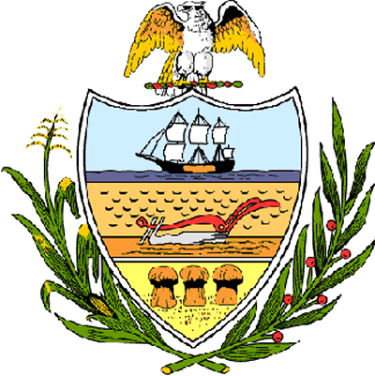

County of Allegheny

Office of the County Council

Certificate of Achievement
Awarded to

Mr. Kevin Michael Halaszynski
Troop #7

This Certificate of Achievement is awarded to you in recognition of earning the rank of Eagle Scout, scouting’s most distinguished honor. We commend you on the diligence and skill you displayed throughout your scouting service, on your growth through Troop leadership positions including Patrol Leader and on the perseverance you displayed throughout your scouting career. This Council extends its deepest appreciation for your service to the community in which you created two bulletin boards, a bench and trail extension at Christy Park/Will Street. You have set a high standard of commitment and dedication which the youth of our great County of Allegheny may follow, and which serves as an inspiration to this Council and the citizens of Allegheny County.

Sponsored by Council Member Bob Macey
Presented on behalf of Allegheny County Council and the citizens of Allegheny County this 6th day of August, 2006.

Attest:

_______________________________
John Mascio
Clerk of Council

