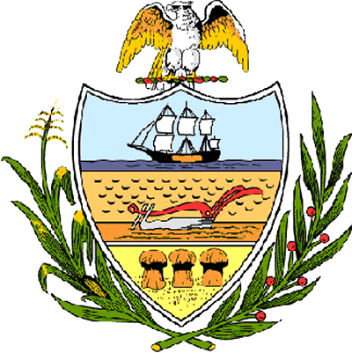

County of Allegheny

Office of the County Council

Certificate of Achievement
Awarded to

Patrick McShane

Upper St. Clair High School – Football and Basketball Teams

Allegheny County Council is proud to present this Certificate of Achievement for being named the “Male Athlete of the Year” by The Almanac and in recognition of your outstanding athletic ability, skill and sportsmanship. This distinguished endeavor and accomplishment is worthy of our County of Champions, earning the esteem of the citizens of Allegheny County. Your achievement has conferred honor upon the County to be shared by each of us and, for that, we commend you.

Sponsored by Council Member Vince Gastgeb, and presented on behalf of Council and the citizens of Allegheny County this 19th day of June, 2007.

Attest:
_______________________________
John Mascio
Clerk of Council

