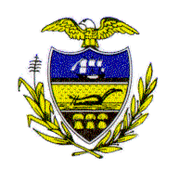Allegheny County Council

Proclamation

WHEREAS, on January 2, 2007, Allegheny County Council adopted an ordinance to prohibit smoking in certain public places and workplaces, and providing for penalties for violations; and

WHEREAS, on May 22, 2007, Pennsylvania’s Commonwealth Court declared that Allegheny County’s ban on smoking in public places is preempted by Pennsylvania’s Clean Indoor Air Act and is therefore, null and void; and
WHEREAS, effective July 1, 2007, Mercy Hospital’s campus will become smoke and tobacco-free to protect patients, visitors and staff from the harmful health effects of secondhand smoke; and

WHEREAS, no tobacco use of any kind will be permitted inside or outside any of Mercy Hospital’s facilities; and

WHEREAS, we commend Mercy Hospital for implementing a policy that promotes the health, safety and well-being of those who work and seek care at Mercy Hospital;

NOW, THEREFORE, BE IT RESOLVED that Allegheny County Council does hereby recognize and thank Mercy Hospital for protecting the public’s health and creating a healthy environment by adopting a smoke and tobacco-free policy.
Sponsored by All Council Members, this 10th day of July 2007.

Attest:

_________________________ __________________________
Rich Fitzgerald John Mascio
President of Council Chief Clerk of Council

