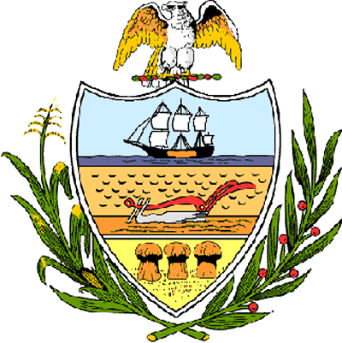

County of Allegheny

Office of the County Council

Certificate of Recognition
Awarded to

Borough of Pennsbury Village

This Certificate of Recognition is awarded to the Borough of Pennsbury Village upon the momentous occasion of its 30th Anniversary Celebration. Nestled in a rustic setting of wooded hills and green lawns, are the 500 townhouse condominium residences that comprise Pennsbury Village. In 1977, the residents bid farewell to Robinson Township, following a court ruling, and the Borough of Pennsbury Village became the 130th municipality in Allegheny County. The first Council of elected officials and a Mayor were elected, and took office in January, 1977. Today, Pennsbury Village is home to some 780 residents and its unique condominium municipality continue to flourish and maintain its very special lifestyle. In recognition of the 30th anniversary, the borough held a Community Day Celebration on July 19-20, 2007 which featured music, food, children’s activities, a flea market, and a craft show. This Council hereby joins with family and friends in celebrating the Borough of Pennsbury Village’s 30th Anniversary and wish the residents continued success and many blessings.

Sponsored by Council Member Michael Finnerty and presented on behalf of Allegheny County Council and the citizens of Allegheny County, this 11th day of September, 2007.

Attest:
_______________________________
John Mascio
Clerk of Council

