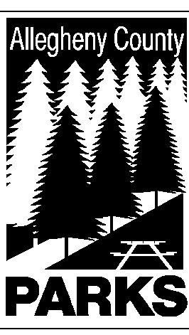

ALLEGHENY COUNTY DEPARTMENT OF PARKS

SUMMARY OF LEGISLATION

TO: WILLIAM McKAIN, COUNTY MANAGER BARBARA M. PAREES, DEPUTY COUNTY MANAGER
STEPHEN E. PILARSKI, DEPUTY COUNTY MANAGER

CC: ANDREW F. SZEFI, COUNTY SOLICITOR
FROM: Andrew G. Baechle, Director of Parks

DATE: April 20, 2015

RE: HARRISON HILLS PARK – HARRISON TOWNSHIP
______________________________________________________________________

The Department of Parks respectfully requests authorization by County Council to permit the continued use of a parcel of land located in Harrison Hills Park by Harrison Township for the purpose of operating and maintaining a leaf composting site.

Please do not hesitate to contact Andrew Baechle at 412-350-2460 if you have any questions or need additional information.

AGB/lg

