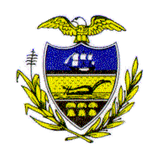Allegheny County Council

Proclamation
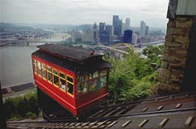

WHEREAS, on May 20, 1877 the Duquesne Incline opened to the public and began transporting both passengers and freight from Mount Washington to downtown Pittsburgh; and

WHEREAS, in 1963 the Port Authority purchased the Duquesne Incline, and from 1964 until the present it has been operated by the Society for the Preservation of The Duquesne Heights Incline; and

WHEREAS, the Society for the Preservation of The Duquesne Heights Incline has helped establish the Incline as a reliable commuter facility and a popular visitor attraction; and

WHEREAS, incredibly, the Duquesne Incline relies entirely on Incline fares collected, membership fees, donations, and gift shop sales;

NOW, THEREFORE, BE IT RESOLVED that Allegheny County Council does hereby congratulate and recognize the Duquesne Incline upon the momentous occasion of its 130th Anniversary. We are truly grateful to have such a wonderful landmark, the Duquesne Incline, which continues to bring much joy to the visitors and residents of Allegheny County.

Sponsored by Council Members Michael Finnerty and William Lestitian and At-Large Council Members John DeFazio and Dave Fawcett, this 20th day of May 2007.

Attest:
_________________________ ___________________________
President of Council John Mascio
Rich Fitzgerald Chief Clerk of Council

