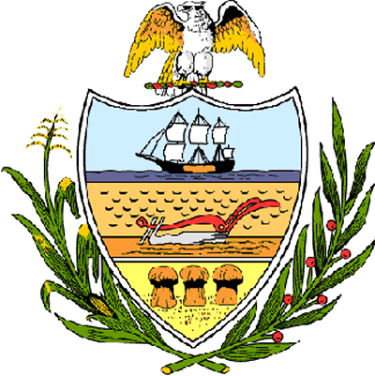

County of Allegheny

Office of the County Council

Certificate of Achievement
Awarded to

Mr. Justin J. Lotz
Troop # 338

This certificate of achievement is awarded to Mr. Justin Lotz, Boy Scout Troop # 338, Greater Pittsburgh Council, in recognition of your earning the rank of Eagle Scout. This proud accomplishment has earned the esteem of the citizens of Allegheny County and this Allegheny County Council. This Council wishes to extend its deepest appreciation to you for your untiring service to the community and for setting a high standard of commitment and dedication which the youth of our great County of Allegheny may follow.

Sponsored by Council Member Joan Cleary
Presented on behalf of the citizens of
Allegheny County by County Council,
This 6th day of June 2004

Attest:

_______________________________
Clerk of Council

