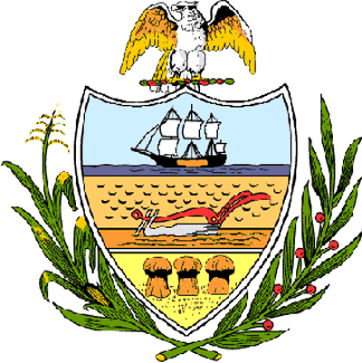

County of Allegheny

Office of the County Council

Certificate of Achievement
Awarded to

Ms. Mallory Jenkins
Brentwood High School
2006 Student of the Year

This certificate of achievement is awarded to you in recognition of earning the Brentwood-Baldwin-Whitehall Chamber of Commerce’s Student of the Year award, a most distinguished honor. We commend you for participating in Brentwood High School’s gifted education program and for your numerous activities including soccer, debate team and drama club. This Council recognizes your acting talent which includes performances in “Meet Me in St. Louis,” “Cinderella” and “The Legend of Sleepy Hollow” and we wish you the best of luck as you audition with Carnegie Mellon University, Point Park University and New York Universities. Your achievement has set a high standard of commitment and dedication which the youth of our great County of Allegheny may follow and serves as an inspiration to this Council and the citizens of Allegheny County.
Sponsored by Council Member Joan Cleary
Presented on behalf of Allegheny County Council and the citizens of Allegheny County this 4th day of April, 2006.

Attest:

_______________________________
John Mascio
Clerk of Council

