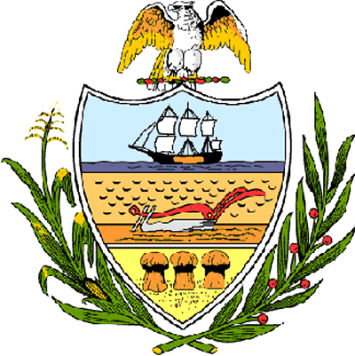

County of Allegheny

Office of the County Council

Certificate of Achievement
Awarded to

NORTH CATHOLIC HIGH SCHOOL – GIRLS’ LIGHTWEIGHT CREW TEAM

Allegheny County Council is proud to present this Certificate of Achievement in recognition of your outstanding athletic ability, a quality clearly shared by your teammates, which contributed to the team’s outstanding season in which it earned the Silver Medal at the 73rd Annual Scholastic Rowing Association National Championship Regatta at Cooper River Park in Camden, New Jersey on May 25-26, 2007. This distinguished endeavor and accomplishment is worthy of our County of Champions, earning the esteem of the citizens of Allegheny County. Your achievement has conferred honor upon the County to be shared by each of us and, for that, we commend you.

Sponsored by Council Member Jim Burn and At-Large Council Members John DeFazio and Dave Fawcett, and presented on behalf of Council and the citizens of Allegheny County this 3rd day of July, 2007.

Attest:
_______________________________
John Mascio
Clerk of Council

