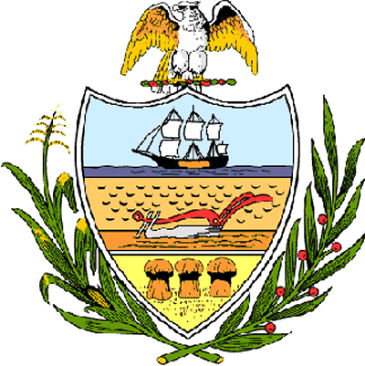

County of Allegheny

Office of the County Council

Certificate of Achievement
Awarded to
White Oak Park Council of Friends

This Certificate of Achievement is awarded to the White Oak Park Council of Friends, an advisory group serving White Oak Park. The Council of Friends leads volunteer efforts to beautify the Park and serves as an important resource for groups, providing information about the many sports and recreational activities, and most importantly, the family fun that can be found within White Oak Park. The White Oak Park Council of Friends commitment and dedication to enhancing the quality of life and well-being of Allegheny County residents is extraordinary. We commend the Council for their vision and leadership which serves as an inspiration to the citizens of this great County of Allegheny and to all.

Sponsored by Council President Rich Fitzgerald, At-Large Council Members Dave Fawcett and John P. DeFazio, Council Member
Bob Macey and presented on behalf of Allegheny County Council and the citizens of Allegheny County this 24th day of October, 2006.

Attest:
_______________________________
John Mascio
Clerk of Council

