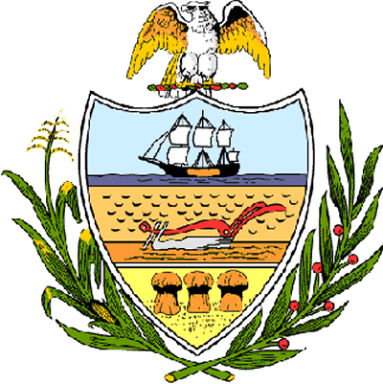

County of Allegheny

Office of the County Council

Certificate of Achievement
Awarded to

Ms. Catherine Greco

2006 Golden Apple Winner

This Certificate of Achievement is awarded to you in recognition of receiving the Diocese of Pittsburgh 2006 Golden Apple Award, a most distinguished honor. This prestigious award is symbolic of excellent performance in the classroom, church and community. As a teacher of biology, chemistry, physics and genetics at St. Joseph High School, you have set a high standard of commitment and dedication which the citizens of our great County of Allegheny may follow, and which serves as an inspiration to this Council and to the residents of Allegheny County.

Sponsored by At-Large Council Members John DeFazio and Dave Fawcett and presented on behalf of Allegheny County Council and the citizens of Allegheny County this 20th day of June, 2006.

Attest:

_______________________________
John Mascio
Clerk of Council

