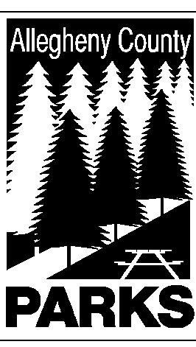

ALLEGHENY COUNTY DEPARTMENT OF PARKS

SUMMARY OF LEGISLATION

TO: JAMES M. FLYNN, JR. – COUNTY MANAGER

MIKE WOJCIK, COUNTY SOLICITOR
CC: DEREK UBER, ASST. COUNTY MANAGER

FROM: Andrew Baechle, Director of Parks

DATE: June 27, 2006

RE: MON VALLEY EXPRESS DRUM & BUGLE CORP

The Department Parks respectfully requests authorization to use the property known as Exhibit Building #8 located in South Park for the Mon Valley Express Drum & Bugle Corp. to practice musical and marching routines for either $200 /month rent or the equivalent in refurbishments/repairs to said facility.

Please do not hesitate to contact Peter J. Wagner at 350-3167 if you have any questions or need additional information.

