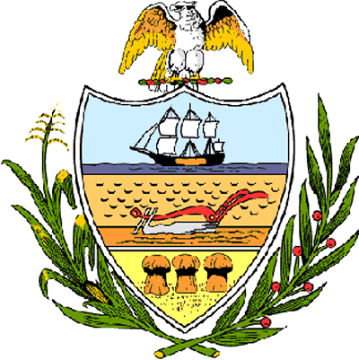

County of Allegheny

Office of the County Council

Certificate of Achievement
Awarded to

Mr. Matthew D. Petersen
Troop # 366

This certificate of achievement is awarded to you in recognition of earning the rank of Eagle Scout, scouting’s most distinguished honor. This Council extends its deepest appreciation for your untiring service to the community of Upper St. Clair in refurbishing and painting a mural and planter wall at the Upper St. Clair High School Stadium. Your achievement has set a high standard of commitment and dedication which the youth of our great County of Allegheny may follow and serves as an inspiration to this Council and the citizens of Allegheny County.

Sponsored by Council Member Vince Gastgeb
Presented on behalf of Allegheny County Council and the citizens of Allegheny County this 24th day of April, 2005.

Attest:

_______________________________
John Mascio
Clerk of Council

