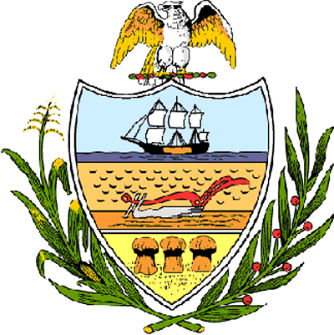

County of Allegheny

Office of the Chief Executive

Community Citation of Recognition

awarded to

Keith Moss, Shane Ireland, Amber Ricci & Paige Gilson

In recognition of your participation in the 2006 Allegheny County Marbles Program and the 83rd Annual National Marbles Tournament in Wildwood, New Jersey; acknowledging your efforts, skill and sportsmanship; we join your friends and family in celebrating your successes and wish you good luck in your future endeavors. And on behalf of the citizens of Allegheny County, we sincerely congratulate you on your accomplishment.

Co-Sponsored by
Allegheny County Chief Executive Dan Onorato &
Allegheny County Council President Rich Fitzgerald &
At-Large Council Members John DeFazio and Dave Fawcett
this 20th day of June, 2006

________________________
Dan Onorato

________________________
John Mascio
Clerk of Council

